**Machine Learning:**

**Supervised learning**

In supervised learning, the machine is taught by example. The operator provides the machine learning algorithm with a known dataset that includes desired inputs and outputs, and the algorithm must find a method to determine how to arrive at those inputs and outputs.

While the operator knows the correct answers to the problem, the algorithm identifies patterns in data, learns from observations, and makes predictions. The algorithm makes predictions and is corrected by the operator – and this process continues until the algorithm achieves a high level of accuracy/performance.

Supervised algorithm is further divided in to two types of algorithms

**Classification:**

In classification tasks, the machine learning program must draw a conclusion from observed values and determine to what category new observations belong. For example, when filtering emails as ‘**spam**’ or ‘not spam’, the program must look at existing observational data and filter the emails accordingly.

**Regression:**

In regression tasks, the machine learning program must estimate – and understand – the relationships among variables. Regression analysis focuses on one dependent variable and a series of other changing variables – making it particularly useful for prediction and forecasting.

Unsupervised learning:

Here, the machine learning algorithm studies data to identify patterns. There is no answer key or human operator to provide instruction. Instead, the machine determines the correlations and relationships by analyzing available data. In an unsupervised learning process, the machine learning algorithm is left to interpret large data sets and address that data accordingly. The algorithm tries to organize that data in some way to describe its structure. This might mean grouping the data into clusters or arranging it in a way that looks more organized.

Clustering: Clustering involves grouping sets of similar data (based on defined criteria). It’s useful for segmenting data into several groups and performing analysis on each data set to find patterns.

**Simple linear Regression: -**

A simple linear regression model estimates the relationship between one independent variable and one dependent variable using a straight line. Both variables should be quantitative.

Simple linear regression is to find the distance between the minimum distance between the variables and the straight fit line.

The aim of Simple Linear regression is to find the best fit line.

Technical Term:

The difference between a real point and a projected point is called Error/Residual

|  |  |
| --- | --- |
| Equation of the straight line | |
| y = mx+c | Or |
| y = β0+ β1+X1 | Or |
| hθ(x) = θ0+ θ1 X | Or |

θ0 =Intercept (where the best-fit line meets the Y axis).

θ1 (Slope) = if there is a unit movement in the x-axis, what the movement in the y-axis is called slope.

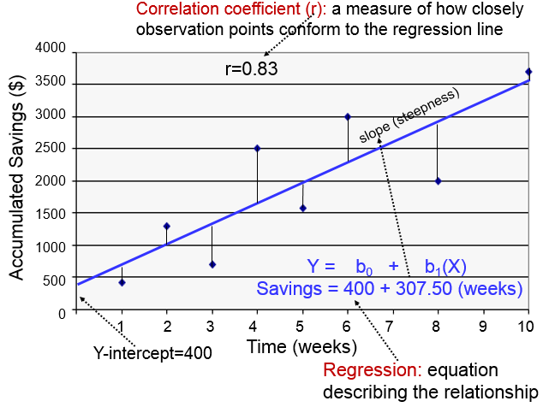

**Cost function:**

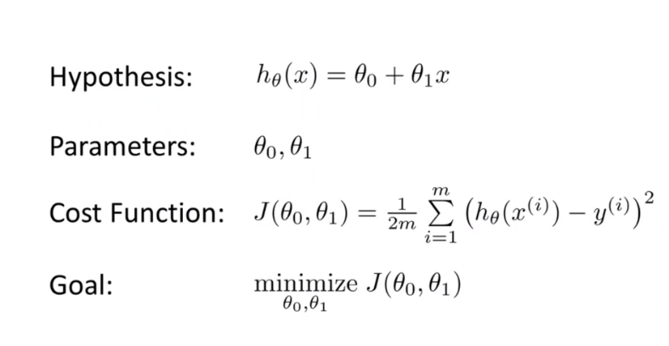

**Mean Square Error:**

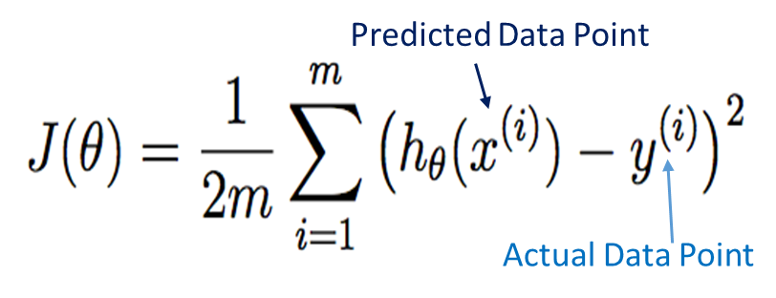

**Gradient decent**

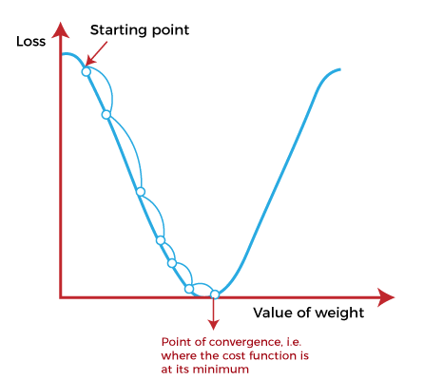

**Convergence Algorythem:**

|  |  |  |
| --- | --- | --- |
| θj= | θj - α | ∂J(θj) |
| ∂θj |

**For –ve Slope**

θj = θj – α (-ve)

**For +ve Slope**

θj = θj – α (+ve)